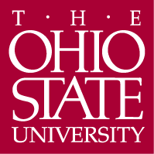

Department of Germanic Languages and Literatures

498 Hagerty Hall
1775 College Road
Columbus, OH 43210-1340

Phone (614) 292-6985
Fax (614) 292-8510

February 18, 2015

To: Meg Daly
From: Carmen Taleghani-Nikazm, Chair-for-the-day of ASCC Arts and Humanities Panel

Re: Approval of Minor in Health, Medicine, and Culture

Dear Meg,

At our meeting on Friday, December 5, 2014 the Arts and Humanities Panel approved a proposal by the department of English to establish an interdisciplinary minor in Health, Medicine, and Culture.

The proposal is motivated by the OSU’s potential for strong interdisciplinary work on the study of health and medicine in social and cultural contexts. The minor draws on a wide range of disciplines across the humanities, social sciences and health sciences for courses that support students’ learning about the social and cultural perspectives of health, disease and medical care

The minor is anticipated to draw a high number of undergraduate students. It will benefit students who are preparing for graduate school in the humanities and social sciences, or careers in health care professions. In addition, the minor and its interdisciplinary course work will benefit students who are planning to take the MCAT exam in 2015 with its newly added content on the social and behavior aspects of medicine. This unique interdisciplinary minor will also be attractive to applicants intending on studying medicine at OSU. In addition, OSU faculty in the humanities and sciences will benefit from the opportunities for collaborative research and interdisciplinary teaching that this minor will provide.

The panel found this proposal to be detailed, clear and thorough and unanimously approved it with two contingencies. The panel asked the department of English to seek concurrence from the College of Medicine, especially the Center for Bioethics and Medical Humanities, and to update the boilerplate language and the format of their advising sheet. The advising sheet has been updated and the concurrence was provided following feedback from the Arts and Humanities Panel.

Respectfully,
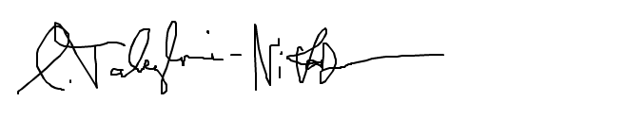

Carmen Taleghani-Nikazm

